Functions in Point-Slope Form Part 1:
From Graph to Formula

Learning Objective: Given the graph of a linear function, express the function in point-slope form as $y- y_{1}=m(x- x_{1})$.

Recall:
y –y₁ = m(x – x₁)

where (y₁, x₁) is a point on the line with slope m.

Activity:
- Lay your laundry line on the tarp grid so it resembles the graph of Function 1.
- Select any point on the line. This will be your (y₁, x₁) in the formula.
- For each unit of x (horizontal change), how much does the y value of the line change? This is the slope of the function, the m in its formula.
- Use the formula you found to calculate the y values in Table 1. Place colored chips on your tarp graph to check your work.
- Repeat steps 1-4 for the functions in Functions 2 and 3.

Function 1
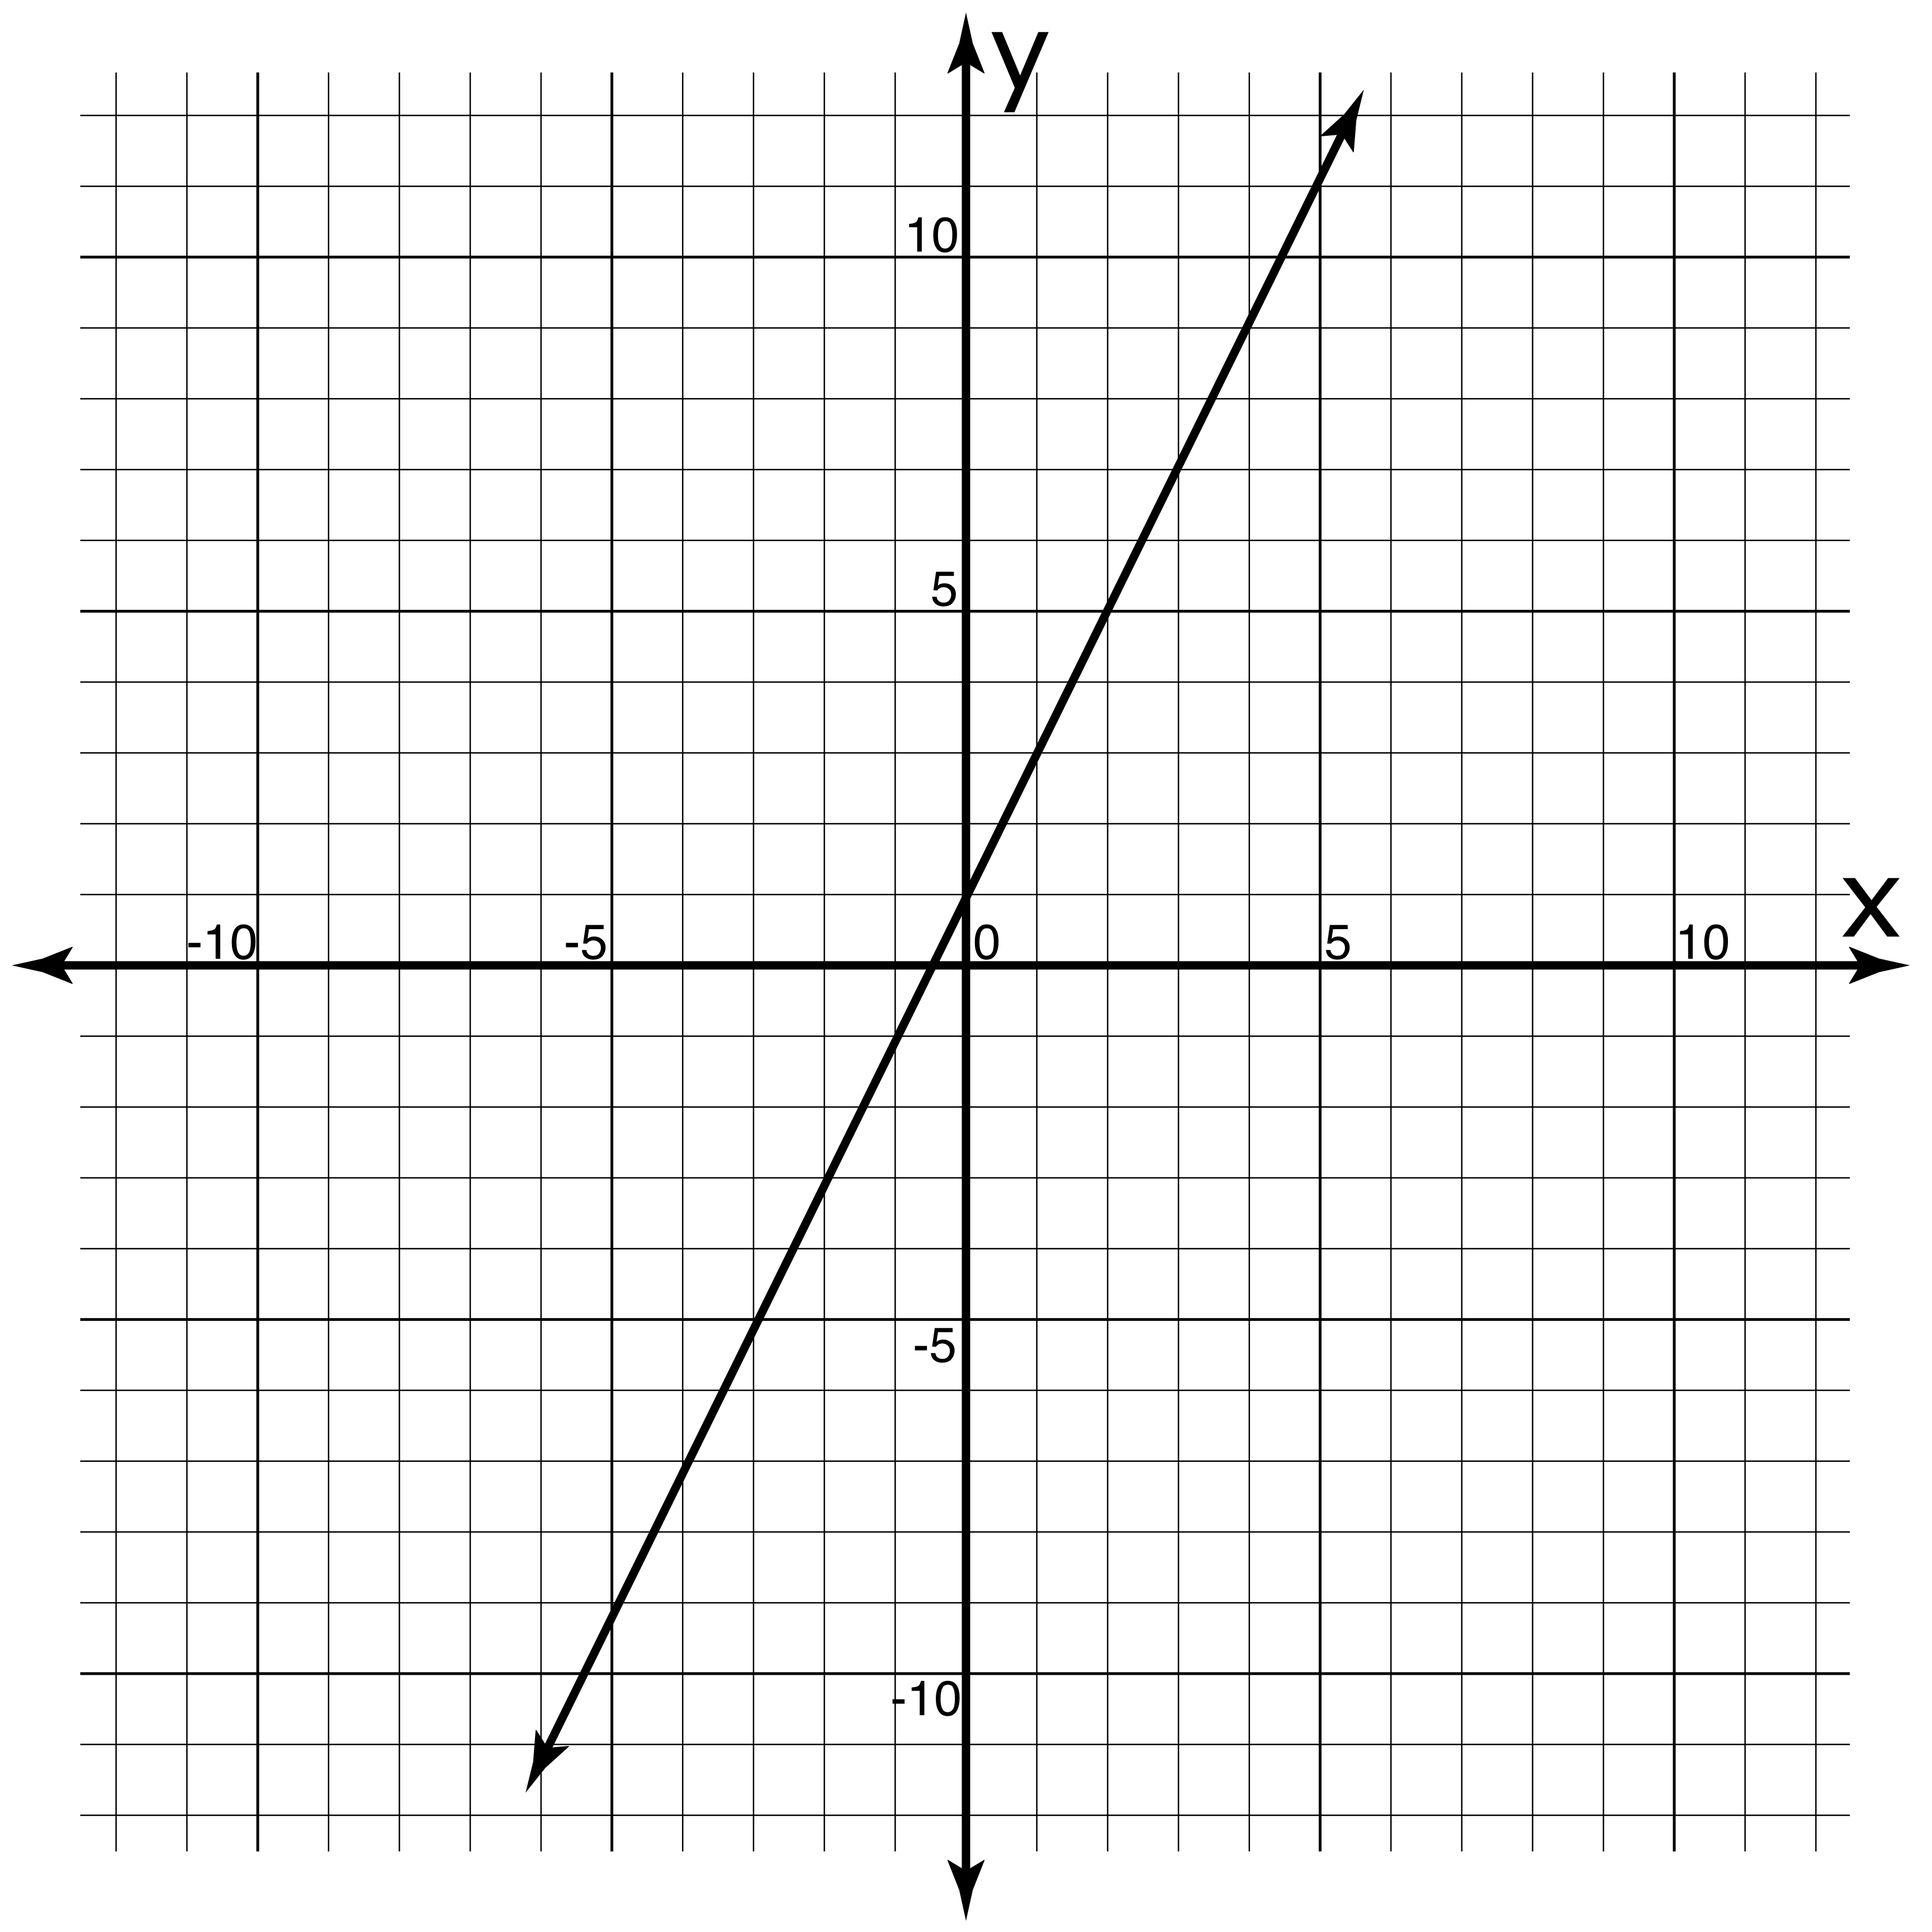
Graph of Function 1:

Function 1 formula:
y - __= __(x - __)

x | y
-10 | ___
-2 | ___
0 | ___
5 | ___
20 | ___

Function 2
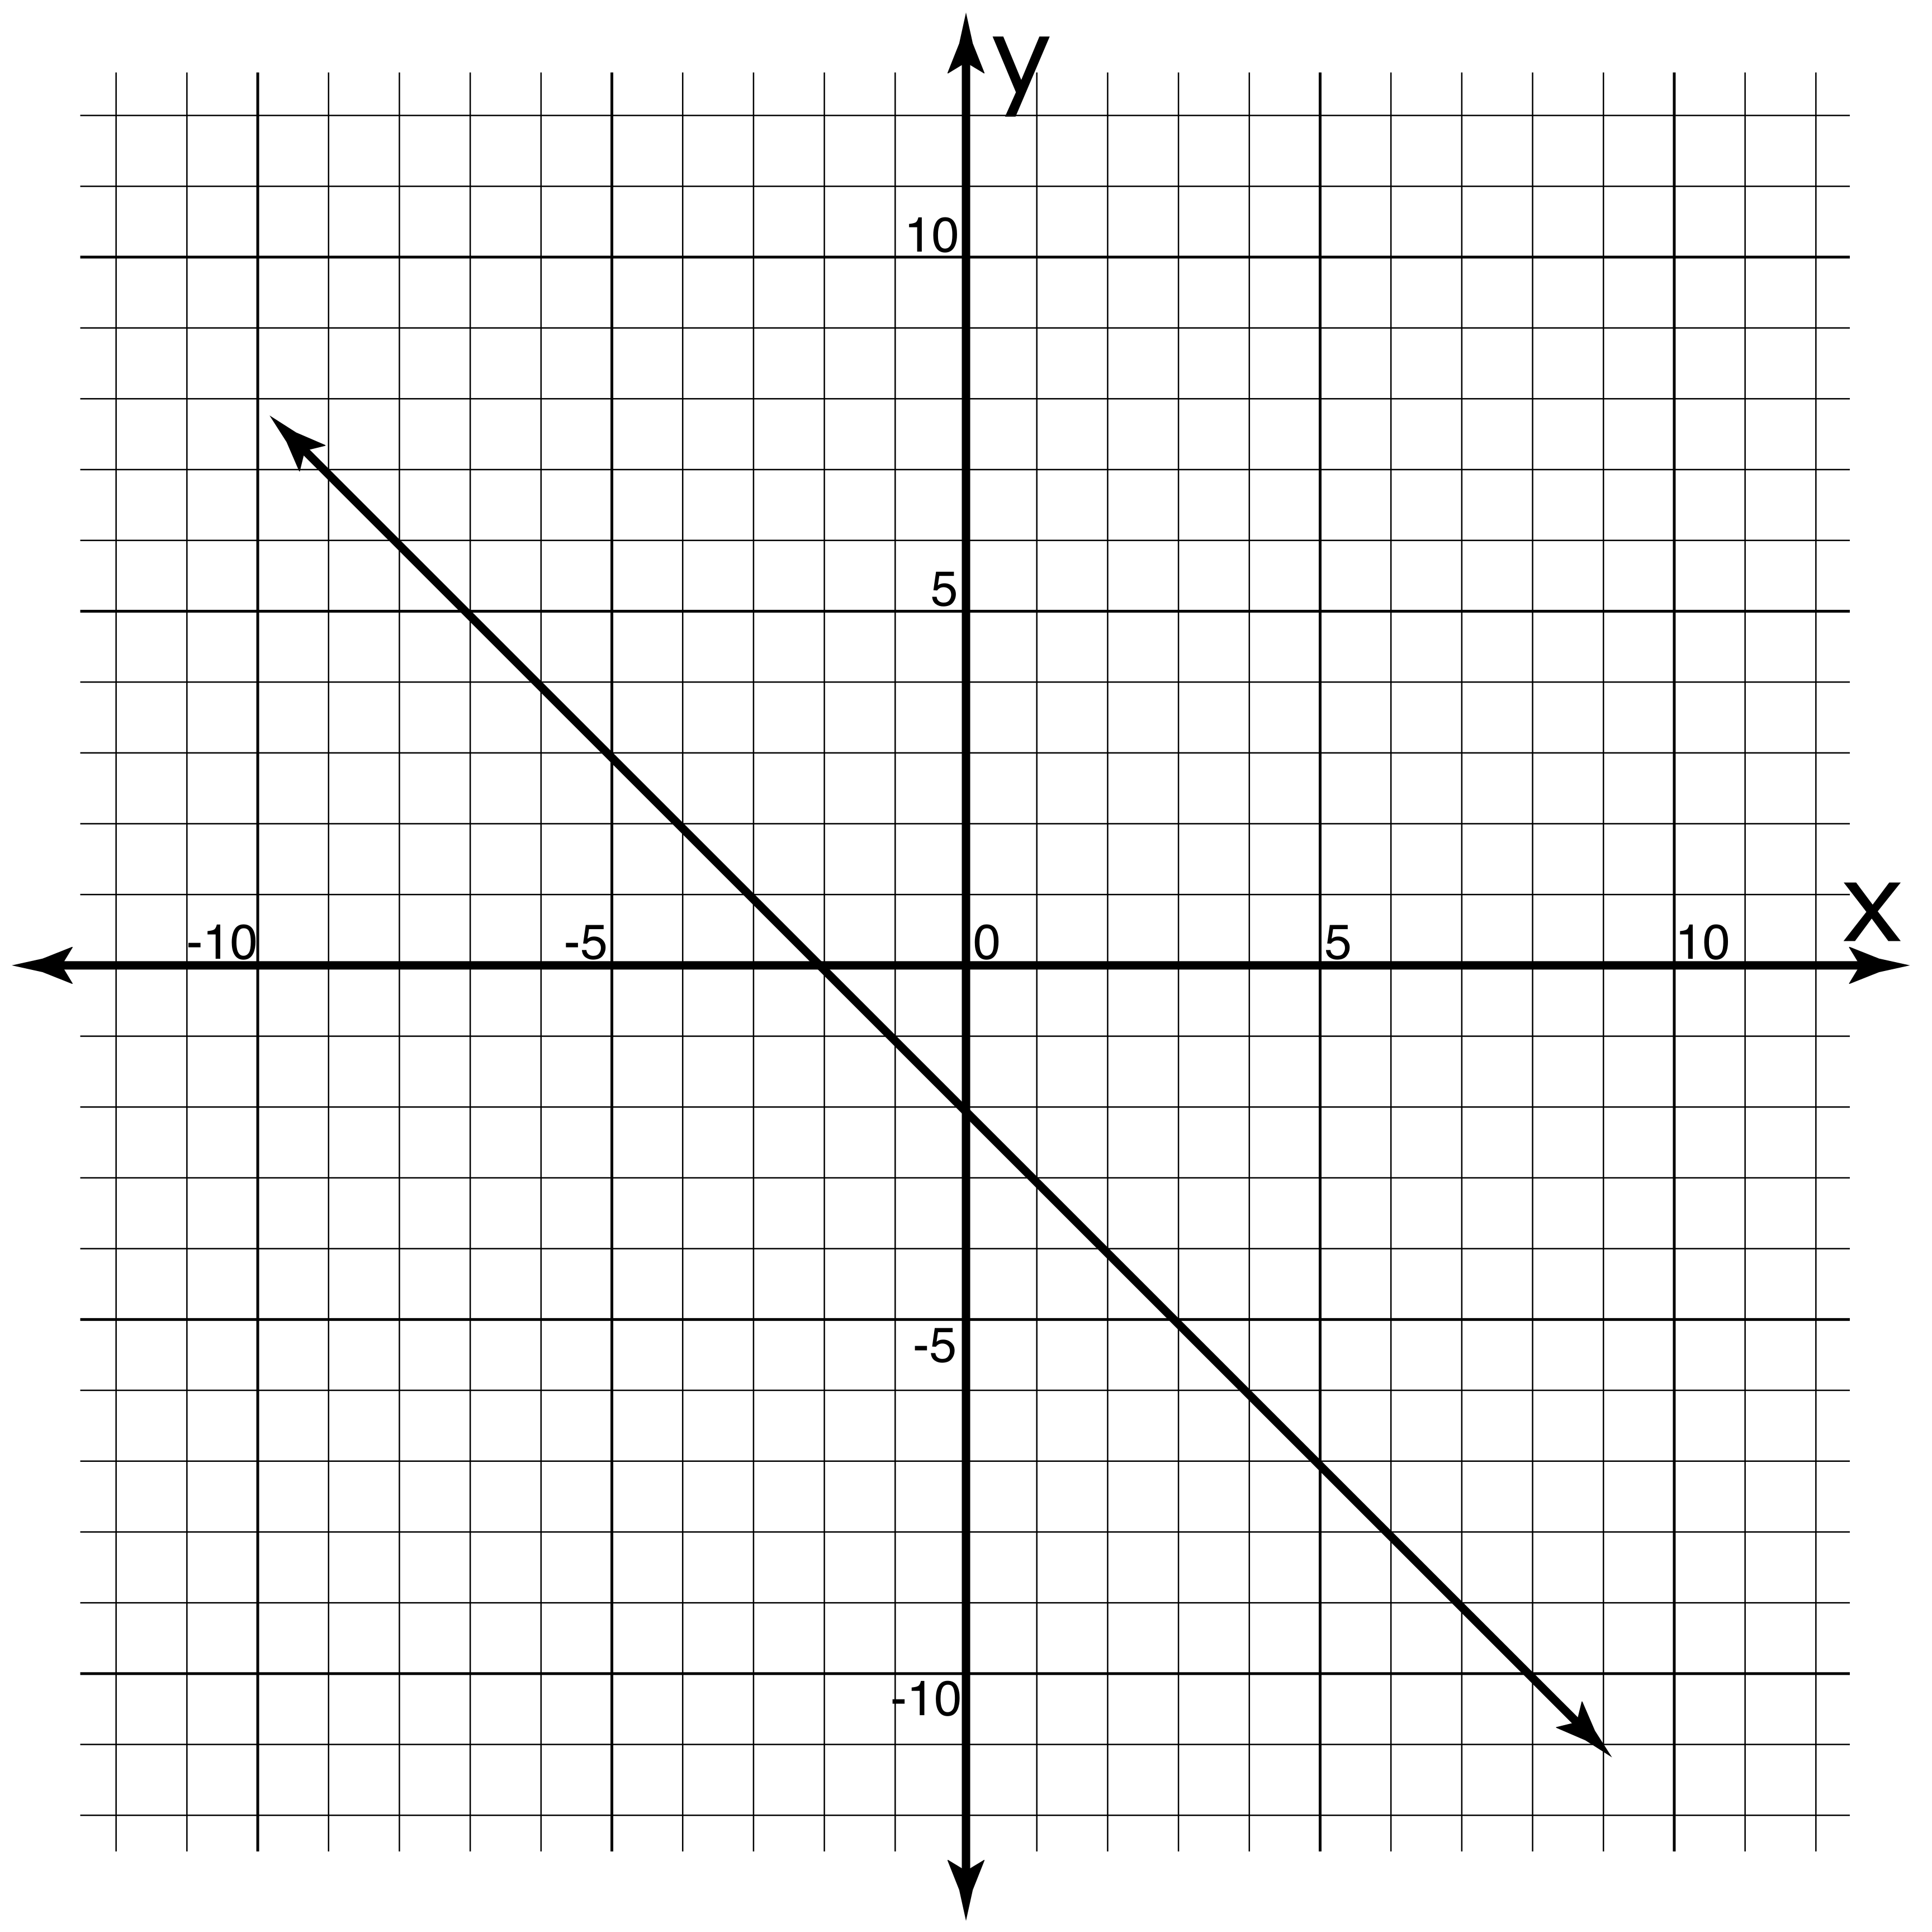
Graph of Function 2:

Function 2 formula:
y - __= __(x - __)

x | y
-8 | ___
-4 | ___
0 | ___
3 | ___
7 | ___

Function 3
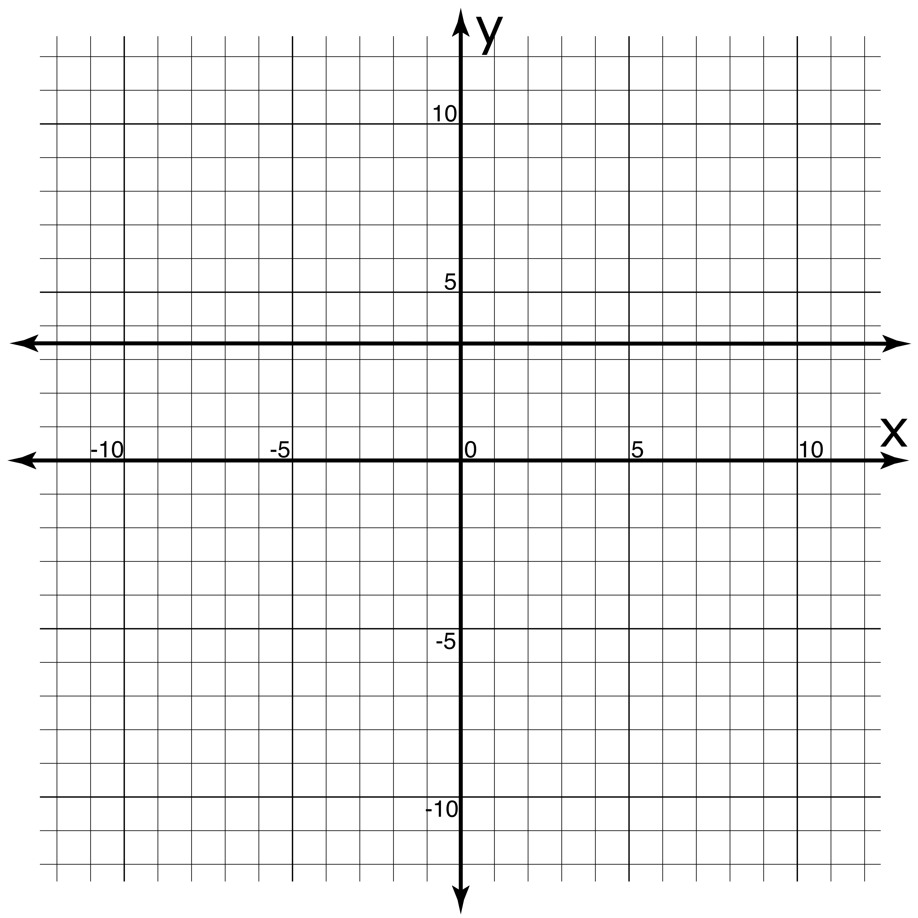
Graph of Function 3:

Function 3 formula:
y - __= __(x - __)

x | y
-15 | ___
-0.5 | ___
0 | ___
6 | ___
19 | ___

Extension:
- Graph a linear function of your choosing on the grid below.
- Select x-values in the table below.
- Exchange this sheet with another group.
- As you did for Functions 1-3, create the graph on your tarp, find the formula for each other’s functions, and complete the tables of values.
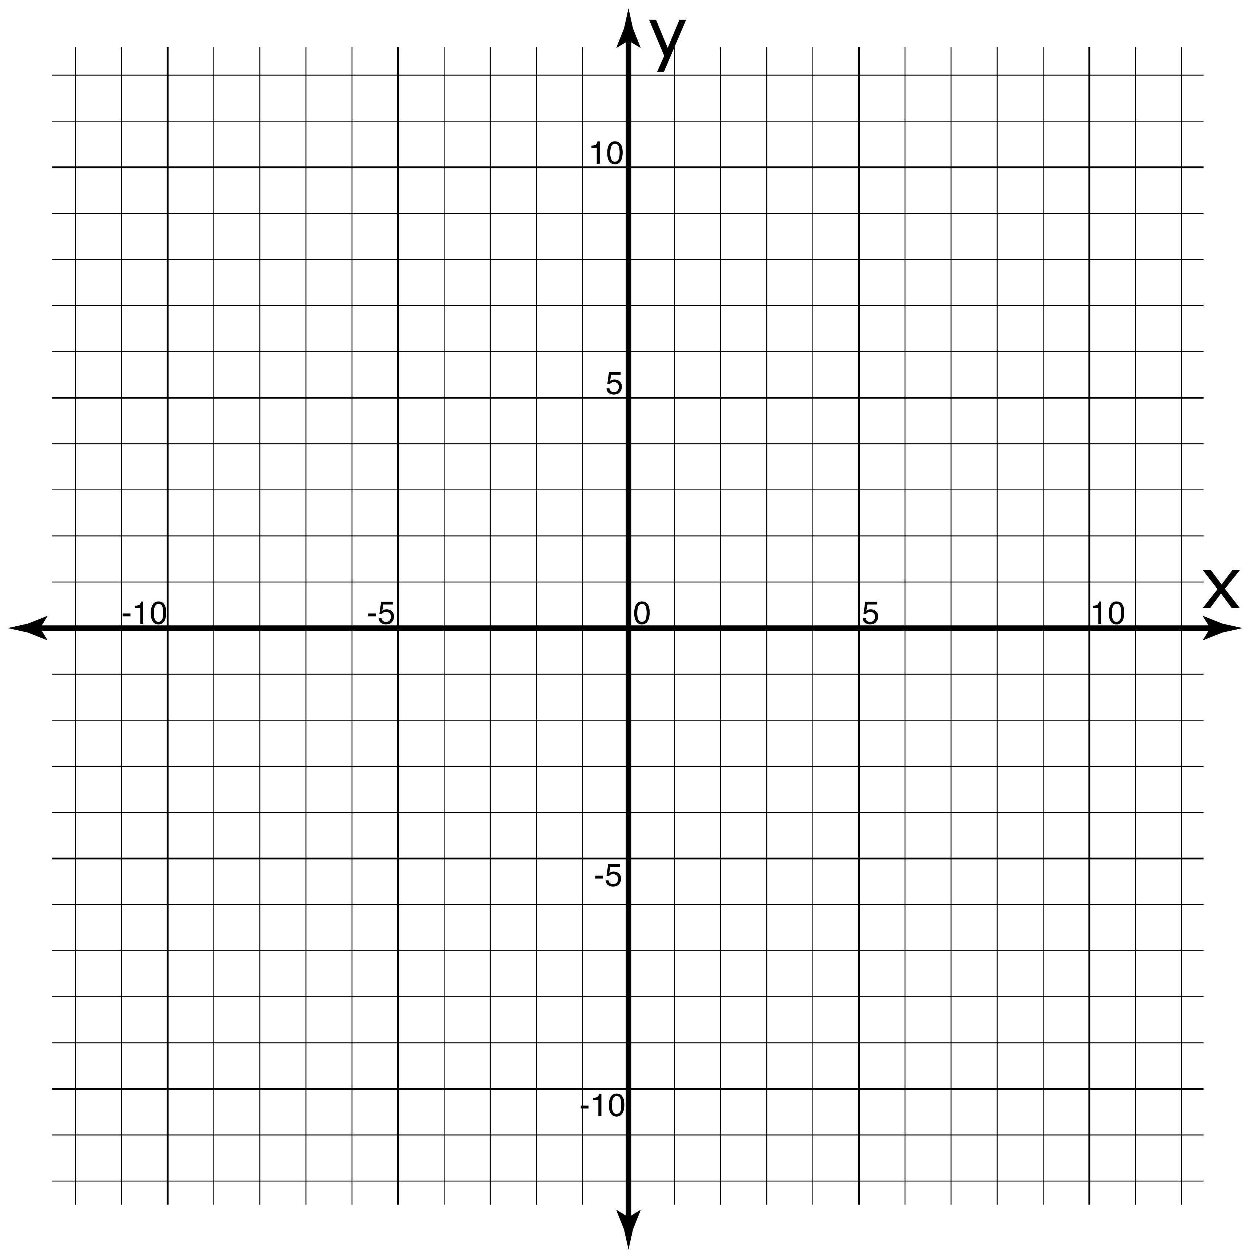
Graph of Your Function:
The function’s formula (for partner group to fill out):
y - __= __(x - __)

x | y
___ | ___
___ | ___
___ | ___
___ | ___
___ | ___

Functions in Point-Slope Form Part 2:
From Formula to Graph

Learning Objective: Given the formula of a linear function in slope-intercept form as $y- y_{1}=m\left(x- x_{1}\right)$, create a graph of that function.

Recall:
y –y₁ = m(x – x₁)

where (y₁, x₁) is a point on the line with slope m.

Activity:
- One person stands on the tarp at (y₁, x₁) as given by the formula.
- Lay a yardstick at your feet, on point (y₁, x₁), so that for each x horizontal unit away, the y value changes by m, the function’s slope.
- Sketch the resulting graph on the small grid provided below. You may need to lay multiple yardsticks end-to-end.
- On the tarp, walk along your graph to find the y-values to complete the table. Verify them algebraically.
- Repeat steps 1-4 for the functions in Functions 2 and 3.

Function 1
Graph of Function 1:

Function 1 formula:
y - 1= 2(x - 3)

x | y
-2 | ___
-1 | ___
0 | ___
3 | ___
8 | ___

Function 2
Graph of Function 2:

Function 2 formula:
y = 0.5(x - 4)

x | y
-8 | ___
-4 | ___
0 | ___
3 | ___
7 | ___

Function 3
Graph of Function 3:

Function 3 formula:
y - 3= -x

x | y
-10 | ___
-3 | ___
0 | ___
4 | ___
7 | ___

Extension:
- Write the formula for a linear function of your choosing in the blanks below.
- Select x-values in the table below.
- Exchange this sheet with another group.
- As you did for Functions 1-3, create the graph on your tarp, sketch is on the blank grid below, and complete the tables of values.
Graph of Your Function (partner group to fill out):
The function’s formula:
y - __= __(x - __)

x | y
___ | ___
___ | ___
___ | ___
___ | ___
___ | ___

