Vector Art – Drawing #1

On your tarp, draw:
- A circle of radius 1 centered at (4,8)
- A circle of radius 1 centered at (9,8)
- A semi-circle of radius 3.5 centered at (6.5, 5) and passing through (3, 5), (6.5,1.5), and (10,5)
- The circle ${(x+9)}^{2}+ {(y+2.5)}^{2}=1$
- The circle ${(x+4)}^{2}+ {(y+2.5)}^{2}=1$
- The semi-circle ${(x+6.5)}^{2}+ {(y+9)}^{2}=1$ and passing through (-10,-9), (-6.5, -5.5), and (-3, -9).

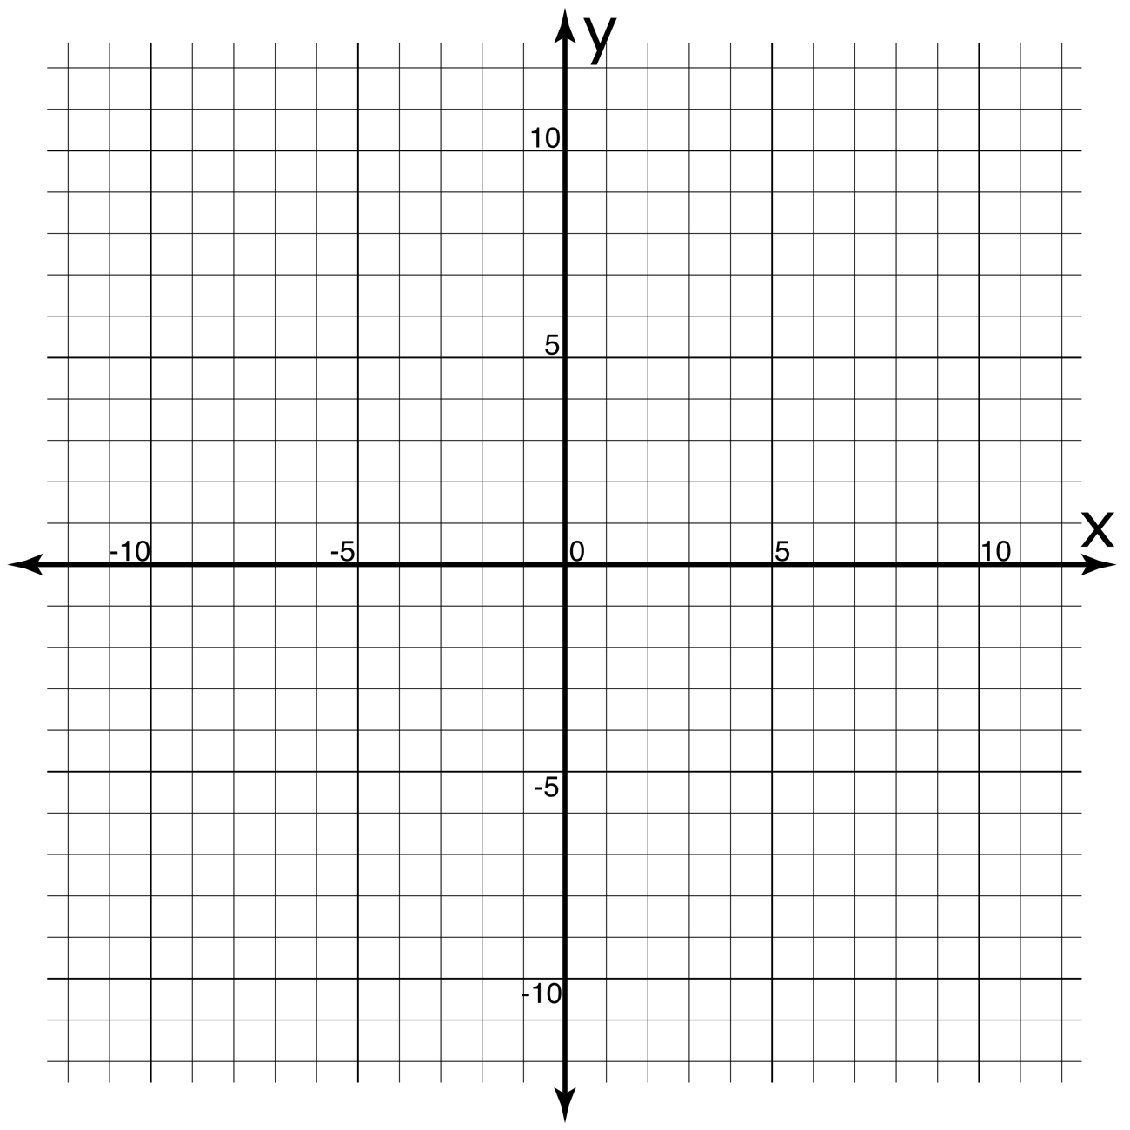
Sketch your result below:

Vector Art – Drawing #1 - KEY

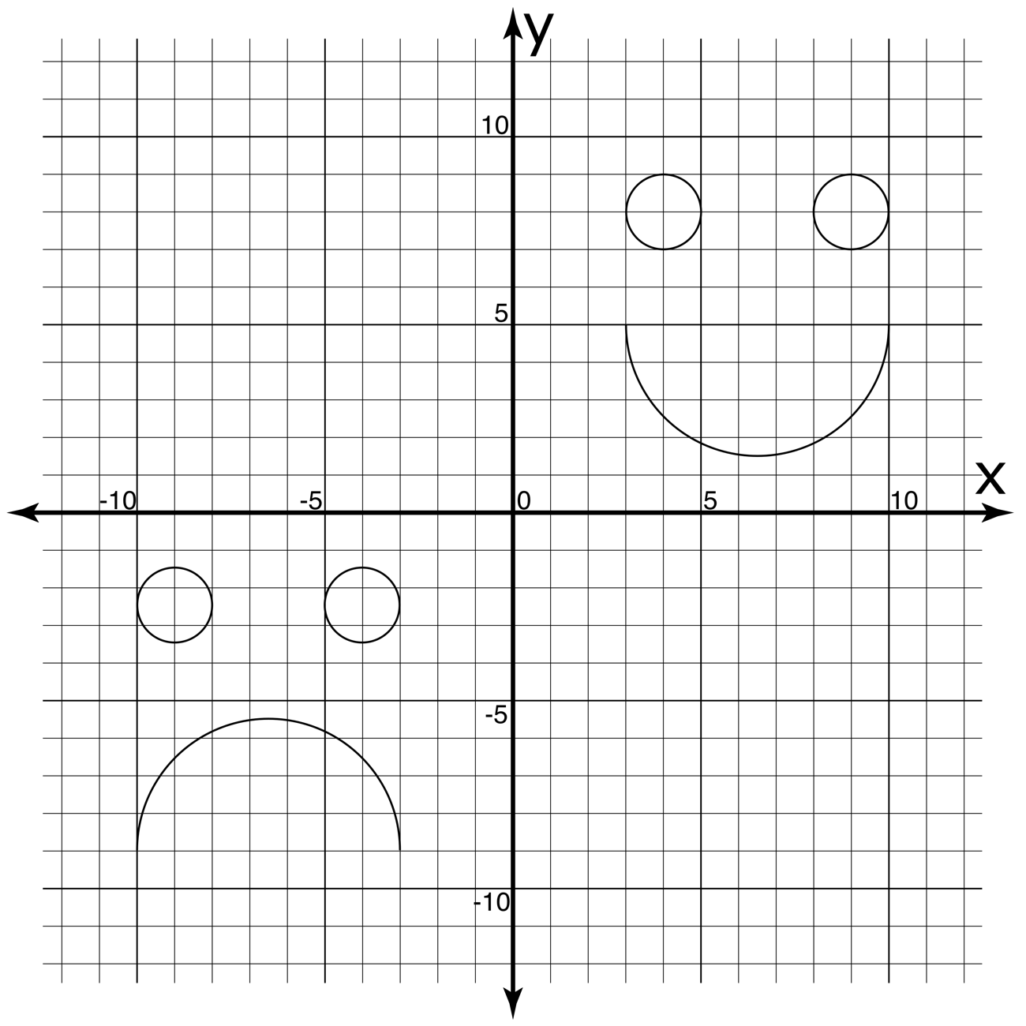

Vector Art – Drawing #2

On your tarp, draw:
- The semi-circle ${(x-4.5)}^{2}+ {(y-12)}^{2}=20.25$ passing through (0, 7.5), (4.5, 12), and (9, 7.5).
- The semi-circle ${(x)}^{2}+ {(y-5.75)}^{2}=3.0625$ passing through (0, 4), (-1.75, 5.75), and (0, 7.5).
- The semi-circle ${(x-9)}^{2}+ {(y-6.25)}^{2}=1.5625$ passing through (9, 5), (10.25, 6.25), and (9, 7.5).
- The segment of $y= {}_{9}^{1}{x+4}$ from (0, 4) to (9, 5).
- The semi-circle ${(x-5.5)}^{2}+ {(y+0.5)}^{2}=12.25$ passing through (2, -4), (5.5, -0.5), and (9, -4).
- The segment of $x=5.5$ from (5.5, -4) to (5.5, -8)
- The semi-circle ${(x-4.5)}^{2}+ {(y+8)}^{2}=1$ passing through (3.5, -8), (4.5, -9), and (5.5, -8).
- The points: (-1.5, -4.5) (-0.5, 2.5) (1, -2)
(1, -9) (4.5, 3.5) (7.5, 0.5)
(9.5, 4.5) (9.5, -7.5) (12, -3)
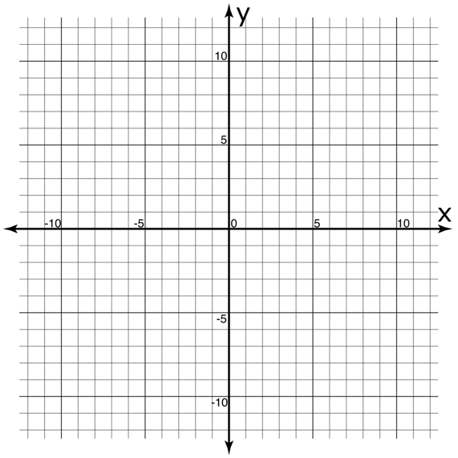
Sketch your result below:

Vector Art – Drawing #2 - KEY

